**Harnessing Mobile Technology for Mental Health Support**

Mahnoor Faisal

900-23-2096

A project submitted in partial fulfilment of the requirements

for the Wrexham University award of

B.Sc. (Hons) in IT

undertaken within the Subject of Cyber and Computing

Faculty for Arts, Computing and Engineering

Wrexham University

April 2025

# Acknowledgements

I would like to express my gratitude to my college teachers and supervisors for their guidance and support throughout the development of my final year project “SupportSpace”.

I am also grateful to my classmates, friends and family for their moral support and ideas during the app development process. My friends and family each tested the final app on their phones and gave me valuable feedback.

Finally, this project has been a transformative learning experience where I overcame countless challenges, grew my skills as a software developer, and deepened my app development knowledge.

Table of Contents

Acknowledgements 1

Abstract 4

List of Figures 5

Glossary 7

Chapter 1 – Introduction 1

Problem Statement 1

Objectives and Scope 1

Significance and Motivation 2

Overview of the Document 2

Chapter 2 – Literature Review 3

Introduction 3

Mental Health in the Digital Era 3

Social Media and Mental Health 5

Overview of Mental Health Applications 6

Mobile Technologies Used in Mental Health 8

Positive User Reviews and Identified Gaps and Challenges 9

Introduction to SupportSpace 10

Conclusion 11

Chapter 3 – Methodology 12

Introduction 12

Development Approach 12

Feature Selection and Design Choices 12

Technologies Used 13

Ethical Considerations and Privacy 13

Conclusion 13

Chapter 4 – Investigation and Analysis 13

Introduction 14

Problem Identification 14

Proposed Solution 14

Conclusion 14

Chapter 5 – Design 15

Introduction 15

Project Overview 15

Project Requirements 15

Design Goals and Objectives 16

System Architecture and User Interface Design 17

Technical Design 22

Data Design and Database Implementation 22

Security Design 26

Development Testing 26

Conclusion 26

Chapter 6 – Implementation and Testing 27

Introduction 27

Implementation Plan 27

Development Environment 27

Coding Standards and Practices 28

Module and Component Development 28

User Acceptance Testing (UAT) 34

Performance Testing 34

Bug Tracking and Errors 34

Conclusion 35

Chapter 7 – Evaluation of the Product 36

Introduction 36

Product Evaluation 36

Conclusion 37

Chapter 8 – Critical Evaluation 38

Introduction 38

Reflections 38

Conclusion 38

Chapter 9 – Conclusions 39

Recommendations for Future Work 39

Closing Remarks 39

References 41

Appendices 42

# Abstract

“SupportSpace” is a mobile mental health support application designed to provide users with accessible and personalised emotional support through advanced technology. This application has multiple features ranging from a personal journal to a mood tracker. It leverages SQLite for offline storage and Google Firebase for secure backend services.

The abstract of a dissertation is a concise summary that provides an overview of the research, its objectives, methodology, findings, and conclusions. See Moodle COM646 for more information. Word count 250-350 words.

# List of Figures

Figure 1: SupportSpace Figma Wireframe

Figure 2: SupportSpace Splash Screen displaying the SupportSpace logo

Figure 3: SupportSpace Welcome Screen.

Figure 4: SupportSpace Sign Up Screen.

Figure 5: SupportSpace Login Screen.

Figure 6: SupportSpace Guest Home Screen.

Figure 7: SupportSpace Logged In User Home Screen.

Figure 8: SupportSpace Logged In User Journal Entry Screen.

Figure 9: SupportSpace New Journal Entry Screen.

Figure 10: SupportSpace Edited New Journal Entry Screen.

Figure 11: SupportSpace Mindful Practices Screen.

Figure 12: SupportSpace Meditation Zone Screen.

Figure 13: SupportSpace Mood History Screen.

Figure 14: SupportSpace Guest Settings Screen.

Figure 15: SupportSpace Logged In User Settings Screen.

Figure 16: SupportSpace Moods SQLite Database

Figure 17: SupportSpace Journal Entries SQLite Database

Figure 18: SupportSpace App Navigation and Firebase Details

Figure 19: SupportSpace App Login Code

Figure 20: SupportSpace App Sign Up Code

Figure 21: SupportSpace Mood Selection Code

Figure 22: SupportSpace Mood Task Suggestions Code

Figure 23: SupportSpace Journal Load Entries Code

Figure 24: SupportSpace Journal Save New Entry Code

Figure 25: SupportSpace Positive Affirmations API Code

Figure 26: SupportSpace Meditation Sound Player Code

Figure 27: SupportSpace App Navigation Code

Figure 28: SupportSpace Firebase Console for Users

# Glossary

**Algorithm:** A step-by-step procedure or set of rules designed to perform a specific task or solve a problem, often used in app features like data sorting, mood analysis, or recommendation systems.

**API (Application Programming Interface):** A set of functions and protocols that allow software applications to communicate with each other. Used in SupportSpace for fetching daily affirmations.

**Authentication:** The process of verifying the identity of a user, typically through credentials like email and password. Implemented in SupportSpace using Google Firebase Authentication.

**Bug:** An error, flaw, or fault in a program that causes it to behave unexpectedly or incorrectly. Bugs were tracked and resolved during development using debugging tools and AI assistance.

**Database:** A structured system for storing, managing, and retrieving data. SupportSpace used **SQLite** as a local database to store user mood entries and journals.

**Debugging:** The process of identifying, isolating, and fixing bugs or errors in code. Tools like GitHub Copilot and ChatGPT assisted in debugging during app development.

**Firebase:** A platform developed by Google offering backend services like authentication, cloud storage, and real-time databases. Used in SupportSpace for user login and sign-up.

**Git:** A distributed version control system that allows developers to track code changes and collaborate efficiently. Used for version control in this project.

**GitHub:** A web-based platform for hosting and managing code repositories using Git. SupportSpace’s codebase was maintained using GitHub.

**IDE (Integrated Development Environment):** A software application that provides comprehensive tools for software development. SupportSpace was developed in **Visual Studio Code (VSCode)**.

**Icon Library:** A collection of pre-designed graphical icons used in user interfaces. Libraries like Entypo, Font Awesome 5, and React Native Material Icons were used to enhance SupportSpace’s UI.

**JSX:** JavaScript XML, a syntax extension used in React Native to write elements that look like HTML but work in JavaScript environments.

**Journalling:**

A feature within SupportSpace that allows users to write and save personal reflections, thoughts, or experiences. It supports mental clarity, emotional expression, and personal growth.

**Meditation Zone:**

A calming section of the app that provides guided breathing or meditation prompts to help users reduce stress, improve focus, and enhance emotional well-being.

**Mood Tracking:** A core feature of SupportSpace that allows users to record and monitor their emotional states over time, enabling personal reflection and pattern identification.

**React Native:** An open-source framework developed by Meta for building mobile apps using JavaScript and React. Used to develop the SupportSpace app for Android devices.

**SQLite:** A lightweight, serverless database engine embedded into mobile apps for local data storage. Used in SupportSpace to store journal entries and mood history securely on the device.

**UI (User Interface):** The visual layout and interactive elements of an application. A focus area in SupportSpace, ensuring ease of use and an engaging user experience.

**UX (User Experience):** The overall experience a user has when interacting with an app or system. SupportSpace was designed with mental health support and ease of navigation in mind.

**Version Control:** A system that records changes to a file or set of files over time so that specific versions can be recalled later. Git and GitHub were used for version control in this project.

# Chapter 1 – Introduction

Background and Context

In recent years, mental health issues have been on the rise globally, and a large number of people are affected by various types of mental illnesses and mental health disorders. In today’s world, mobile phones and applications play an important role in everyone’s life. Alongside the rise of mental health concerns, there has been a rise in mental health-focused websites and applications. **[1]**

I have developed a mental-health support application named “SupportSpace”, which aims to combine technology with mental-health-focused resources to provide users with a platform for emotional support while ensuring user privacy and a seamless user experience.

The application is built on VSCode using various technologies and frameworks, such as React Native, JavaScript, Expo, Google Firebase, and SQLite. This project is situated in the field of mental health technology, addressing the need for timely and consistent support.

## Problem Statement

Nowadays, most mobile users prefer sophisticated and interactive apps over self-help tools and traditional therapy. Therapy tends to be expensive and some people prefer to use apps on their mobile phones for privacy and comfort. This project aims to develop a mobile app that offers emotional support, self-help tools and comfortable ambience. **[1]**

## Objectives and Scope

There are multiple objectives to this project:

* Develop a friendly and interactive interface for mental health resources and accessible features.
* Design a personal journal for users to write down their thoughts and feelings.
* Integrate a mindful tasks feature that recommends helpful tasks to users.
* Design a mood tracker for users to input their moods.
* Implement a meditation feature so users can meditate to different audios with a timer.
* Design a motivation library containing mental-health support resources like articles and links
* Implement Firebase for secure backend services and user authentication.
* Conduct user testing and feedback sessions for continuous improvement.

## Significance and Motivation

“SupportSpace” aims to benefit people with mental health needs by offering a safe and supportive digital platform. The technologies used are popular and well-known already; however, as a junior app developer, I was able to teach myself new techniques and contribute to the advancement of mental health technology. The main motivation for this project was the mental health issues faced by friends and family. Through their suggestions, the app features were designed accordingly.

## Overview of the Document

In this report, I will be covering every aspect of the app development process, from the planning and wireframe designs to the implementation and final evaluation. Alongside this, I will explain how mobile technology can harness mental health issues with the help of research papers and a literature review.

# Chapter 2 – Literature Review

## Introduction

This chapter will discuss and review existing mental health support systems, mobile applications and technologies used in mental health management. This review aims to identify gaps and limitations in current solutions, highlight the role of digital tools in mental health support, delve into the impact of social media on mental health, explain what makes a good mental health app and introduce SupportSpace.

First, we explore the digital era and examine the technologies that are transforming the mental health care world. Next, we analyse existing mental health applications and critically assess the mobile technologies they utilise. Following this, we identify key gaps or challenges across different contexts while analysing user reviews. Lastly, we discuss how the “SupportSpace” application can be effectively utilized by individuals and integrated into mental health care systems.

Multiple research papers and articles are referenced for use in this literature review.

## Mental Health in the Digital Era

Mental health problems impact over one billion people worldwide each year, with depression representing the leading cause of disability across the globe. There has been a significant rise in mental health issues globally. The COVID-19 pandemic has significantly boosted the use of telehealth and mobile mental health technologies, such as smartphone apps, virtual reality, chatbots, and social media platforms. **[2]**

The arrival of the COVID-19 pandemic has accelerated the growing interest and access to digital health technologies (DHT). A study taken in 2021 states that 17 different countries reported an overall increased use of digital health in mental health care settings, as well as renewed support for facilitating updates during the pandemic. This is due to innovations in mental health care technologies that enable DHTs to deliver scalable, affordable and accessible mental health care solutions. **[2]**

The article *“The growing field of digital psychiatry: current evidence and the future of apps, social media, chatbots, and virtual reality”* **[2]** highlights the widespread accessibility of smartphones and their potential impact on mental health support systems. According to 2018 survey data, 76% of people in advanced economies and 45% in emerging economies owned a smartphone. Despite the digital divide, smartphone ownership is rapidly increasing in different regions, making digital mental health support more accessible than ever before.

More recent data from the United States reveals that nearly 70% of individuals with severe mental illness also own a smartphone. **[2]** This statistic is significant as it represents that even the most vulnerable people who face barriers to traditional mental health services can now access mobile-based mental health solutions. The growing global adoption of smartphones, even among lower-income and marginalized communities, provides an opportunity to bridge the gap in mental health care through mobile technology.

Despite the digital divide, where those in rural areas or without access to the internet and mobile devices will eventually have access to some form of smartphone technology, most of the population will eventually have access to some form of smartphone technology. This opens the market for virtual therapy sessions, mental health support apps, AI-powered chatbots, and self-help platforms to reach a much broader audience.

Data is collected either actively or passively. Active data typically refers to smartphone-based surveys like active symptom monitoring or momentary assessment, which are completed by the user and saved on the app. Smartphones can be used for cognitive assessment and for remotely monitoring symptoms with promising results, even for severe mental illness such as schizophrenia. In contrast, passive data is automatically obtained through sensors, either on a wearable device or phone, ranging from user metrics to accelerometry, global positioning system (GPS) and even biometrics like voice tone or facial expression data. **[2]** According to the data collected, mental health support software and apps can provide the user with customised suggestions for the management of wellbeing and various conditions like depression, anxiety, bipolar disorder and more.

The vast and varied nature of passive data—encompassing metrics like step counts from wearables, text analysis from social media, metadata from electronic medical records, and greenspace exposure from geolocation—requires advanced data science techniques. Artificial intelligence and machine learning play a crucial role in combining and analyzing this 'big data' to extract meaningful insights for mental health care. The continuous advancements in artificial intelligence and machine learning will further enhance the translation of new data into digital biomarkers. These biomarkers represent quantifiable behavioral information that can indicate patterns related to mental health conditions, including self-harm tendencies and suicide risk. By utilising these technologies, mental health interventions can become more proactive, personalized, and effective. **[2]**

Due to the advancements in mental health technology, promising results are found for various mental health conditions and outcomes. One instance is Anomaly Detection involving the use of smartphone sensor data. This can help predict relapse risk in people with schizophrenia. Preliminary studies have demonstrated promising results however, large-scale studies must be carried out to validate these findings and refine this technology. **[2]**

Overall, while both active and passive data collection methods have great potential for precision psychiatry, several challenges remain. These include ensuring the validity and reliability of digital biomarkers, determining how best to interpret and represent the collected data, and addressing ethical concerns surrounding data privacy and clinical integration.

## Social Media and Mental Health

Social media plays a complex role in mental health. Social media can represent both a means to quantify mental health as well as a source of both positive and negative interactions. A popular belief is that too much screen time and social media use is detrimental to mental health. However, recent studies show that social media can be a positive form of support to users. For example, during the COVID-19 pandemic, social media became a source of social support for those who were coping with isolation and loneliness. **[2]**

While excessive social media use and screen time are not beneficial for mental health, *the quality of social media use and screen time is more important than the quantity.* Research suggests that meaningful and positive interactions such as positive conversations and mental health advocacy, can foster emotional well-being. In contrast, passive scrolling or “doomscrolling”, which is exposure to harmful content and unhealthy comparisons with others, can contribute to poor mental health and conditions like anxiety, depression and low self-esteem. Recognising this, companies like Facebook and Instagram have been flagging content related to self-harm or suicide, while offering crisis resources and support to users in distress. **[2]**

Social media can also be used as a therapeutic tool. Newer research has shown promise that social networks can serve the youth with diverse mental health needs. For example, the PRIME app has built a supportive and personalised social community for people with schizophrenia to navigate functional recovery while mitigating negative symptoms. Another example is The Moderated Online Social Therapy (MOST) platform, which offers personalised therapy combined with social connections. **[2]**

While social media can be a valuable tool for mental health management, offering spaces for community support and awareness, it is not without risk. Research implies that there is a need for a balanced approach in moderation. There is also plenty of misinformation, exposure to harmful content and the reinforcement of negative self-perceptions. Additionally, stigma surrounding mental health remains on digital platforms, often discouraging users from seeking help. For social media to be used positively, users and companies must promote responsible engagement, filtering, content moderation and integration of reliable mental health resources.

## Overview of Mental Health Applications

Numerous mobile applications supporting mental health exist online now. According to *“Annals of Family Medicine”* **[3]**, thereare thousands of commercially available mobile applications for mental health. These offer tools for self-diagnosis, monitoring, symptom management and treatment. One meta-analysis found that users with depression experienced a decrease in their depressive symptoms from using a mental health app, although some other studies found that computerized cognitive-behavioural therapy has no benefits beyond the usual clinical care. Only a small fraction of apps are evidence-based or clinically validated.

A study conducted in 2016 **[3]** revealed that most app materials delivered a strong message that mental health problems existed for everybody. However, the design and language reflected biases and a lack of diversity. Some app descriptions tended to represent users as employed, white and in a family. For example, the app Calm Down Now highlighted everyday problems being “jet-lag”, “work stress” and “a baby waking up at night”, suggesting a narrow target audience and ignoring broader socio-economic and cultural contexts. Very few apps implied that mental health symptoms might be a normal reaction to external stress.

In contrast, the past decade has witnessed a notable shift towards inclusivity and broader representation in mental health applications. Already there have been extraordinary developments: over $10B invested by venture capital firms since 2017, 10 new companies valued at over $1B, and hundreds of thousands of patients receiving care from telepsychiatry companies that did not exist five years ago. **[4]** This is only the beginning of digital mental health care.

However, challenges exist in the rapidly growing industry. For instance, one of the fastest-growing companies is under investigation by the Department of Justice for alleged over-prescribing of psychiatric medications. Stricter regulatory frameworks, enhanced oversight and human intervention must be put in place to prevent similar occurrences. Another Senate investigation has been launched into potential privacy violations involving three of the largest tele-mental health companies, highlighting systemic concerns around data handling and confidentiality. **[4]**

It is important to recognise that digital mental health technology is a fairly young field that is constantly growing. One important lesson from *“npj Digital Medicine”* **[4]** is that technology is only part of the answer. Even with the promise of artificial intelligence and autonomous agents, diagnosis should still involve a human interview collecting patient data. While technology plays a significant role in mental health diagnostics, it is still prone to errors; therefore, human oversight and intervention remain essential to ensure accurate and ethical assessments.

Another important lesson from *“npj Digital Medicine”* **[4]** is that digital mental health companies are not traditional tech companies. Tech companies focus on user experience, data collection and iterative learning, which can improve the impact of mental health care. However, the software engineers or computer scientists founding mental health companies may not have a proper understanding of clinical complexity and the mental health issues users face. They may end up building the wrong products or solving the wrong problems. An easy fix is to involve a Chief Medical Officer who will guide the app developers. Unfortunately, very few mental health companies are led by actual certified experts.

Mental health technology is not only changing rapidly, but progressing on a non-linear course. AI tools for analysing speech, voice and face emotion are evolving faster than traditional biomedical research, potentially reshaping mental health diagnosis and treatment. Successful tech companies design products based on user preferences and needs, providing helpful support for increased engagement in mental health care, especially for the youth. Tech companies also use real-time data to improve engagement and outcomes, demonstrating the value of a learning-based care model. **[4]**

Finally, apps enable people to attend to their health while promoting the idea that individuals should take personal responsibility for their health. While app-based treatments may suit many users, apps must be able to enable frequent self-monitoring, personalised feedback and consistent therapeutic engagement. By enabling ongoing interaction and reflection, these apps have the potential not only to supplement traditional therapy but also to foster long-term behavioral change and emotional resilience in users. **[3]**

Some innovative companies are harnessing the potential to support mental health. By combining mental health professionals and technological advancements, more accessible and effective mental health solutions are available.

One widely used app is Calm, a meditation and mindfulness app designed to help people reduce stress, improve sleep and manage anxiety. It offers various guided meditations, breathing exercises and an extensive library of sleep stories to aid relaxation and improve sleep quality. The app leverages user data for personalised recommendations and progress tracking to enhance engagement and effectiveness. **[5]**

Another online therapy platform is Talkspace, which connects people with licensed therapists for video, audio or text-based therapy sessions. This platform is designed to improve accessibility and affordability by offering flexible subscription plans. Users can communicate with therapists at any time, making it a convenient alternative to traditional in-person therapy. Talkspace also incorporates secure messaging and regular progress tracking, empowering users to take an active role in their mental health journey. **[5]**

Finally, Happify combines gamification with a traditional mental health app to promote emotional well-being. This app offers various games and activities designed to teach people positive thinking skills and develop a more positive outlook on life. Its structured tracks are designed to target specific goals such as reducing stress, building self-confidence, or coping with major life changes.The app personalises user experience based on user experiences and progress, making this unique app engaging and user-friendly. **[5]**

## Mobile Technologies Used in Mental Health

Modern mental health mobile applications incorporate a variety of technologies. With technological advancements over time, the collection of digital mental health tools has broadened considerably, now encompassing a wide range of applications designed to offer a wide spectrum of mental health interventions. Firstly, mobile mental health support apps and self-help tools provide resources and strategies for managing anxiety and depression. These apps usually include mood tracking, relaxation exercises, cognitive-behavioural therapy (CBT) exercises and psychoeducation to empower individuals to monitor and improve their mental well-being. **[5]** These apps utilise machine learning to design interventions according to users’ needs, creating a personalised support system.

Online therapy and telehealth enable individuals to access therapy and counseling services remotely from their devices. Evidence-based treatment like CBT can be done through video calls or messaging. Platforms like BetterTherapy and TalkSpace provide professional licensed therapists and a range of communication options to suit users’ needs. This is great for those living in rural areas, those with physical disabilities or those with social anxiety who might find face-to-face interactions intimidating. **[5]** Users can receive regular notifications and reminders from their mental health app, encouraging consistency in mental health practices.

Most mental health support apps and platforms provide AI-powered chatbots and virtual assistants that can offer users immediate emotional support and resources related to common conditions such as stress, anxiety and depression. These tools use natural language processing (NLP) to engage users in conversational dialogue, stimulate therapeutic interactions and guide users through actions like deep breathing exercises. These tools can also redirect users to mental health professionals within the app. Finally, these AI systems are available 24/7, making them a reliable tool for individuals seeking help but not yet ready for traditional therapy. **[5]**

## Positive User Reviews and Identified Gaps and Challenges

According to the research and studies carried out in the “*Health Informatics Journal”* **[6]**, users appreciate apps that present them with a variety of options, functionalities and content they can choose from. There are more than 10,000 mental health and wellness apps providing meditation, information, symptom tracking, social support and more available for download, but only a few specific ones receive high ratings. Many apps have not been evaluated for effectiveness, usability and safety.

While some studies show that mental health apps could be effective at reducing mental health issues, they also highlight how these apps have high dropout/ attrition levels. As there is no clear evidence on why many mental health apps experience high dropout rates, more examination must be carried out on app efficiency, user experience and satisfaction from the user’s point of view. For an app to be effective, users must use it for a long time. **[6]**

In the *“Health Informatics Journal”* **[6]**, researchers analyzed user reviews from 106 mental health apps available on both the App Store and Google Play to identify key themes and detailed insights. The results showed that users appreciate user-friendly apps with a well-designed customisable user interface (UI). Apps with a large variety of options, functionalities and customisable content are more engaging for users. In contrast, apps with poor usability and a lack of options, personalisation, customer service, trust and security lead to app abandonment.

Popular apps are those that enable self-monitoring of personal mental health-related data like mood fluctuations, sleep patterns, energy levels and emotional triggers. The most effective apps use various evidence-based techniques aimed at enhancing self-awareness and emotional regulation. These techniques include tracking and monitoring to improve personal insight about causes and symptoms of mental illness, providing techniques to mitigate and manage symptoms emerging as a result of a mental health issue, such as breathing and meditation, and providing a social community where users can ask and/or answer questions and find support. This sense of community not only reduces feelings of isolation but also reinforces user engagement. **[6]**

Another study about poor app usability revealed that more than 50% of participants with a depressive disorder experienced some degree of difficulty and spent too much time entering and accessing their mood data. Other usability issues in mental health apps are bugs, poor UI design, data loss, memory and battery usage issues, lack of guidance, internet connection issues, and missing important features. Another issue preventing users from using an app is a lack of privacy regulations. Out of 600 health apps, only 183 provided privacy policies. Finally, apps that do not meet the user's needs and lack most of the desired functionality. **[6]**

Users need to be wary of the mental health apps they use. While a few mental health apps are based on evidence, a tremendous number (more than 10,000) of currently available apps are not based on scientific evidence, and some may even be harmful. **[6]** This causes a lack of trust for both users and healthcare providers, contributing to low engagement.

To conclude, companies must carry out adequate research to understand the opinions and experiences of users. Only after analysing user reviews and carrying out evidence-based research can companies develop a solid mental health app that satisfies user needs.

## Introduction to SupportSpace

SupportSpace is a mental health support application with various features aimed at improving well-being. As it has been developed by an amateur coder, the app is relatively simple and not highly advanced.

However, it focuses on personalisation and ease of use. It is easy to use for all ages, though it is aimed at adults. Features like mood-based task suggestions, offline journaling and local data storage for privacy make it an accessible and beginner-friendly app.

## Conclusion

This literature review reveals detailed insights into various mobile technologies used, how mental health data is collected, and challenges found in these apps. SupportSpace is positioned to address these through targeted features that improve engagement, privacy, and accessibility.

# Chapter 3 – Methodology

## Introduction

This chapter outlines the research and development approaches used to design and build the SupportSpace application. While no formal methodology was followed, a trial-and-error development process was guided by practical decisions, user needs and technical improvements.

## Development Approach

Before developing the application, extensive research was conducted on mobile technologies and frameworks suitable for building a mental health support app. There was a lot of trial-and-error when designing and developing the application. Since this was my first major app development project, the process involved a great deal of trial and error.

I explored various technologies, comparing their advantages, limitations and ease of use. I selected React Native and Expo Go as it's beginner-friendly and cross-platform compatible. Firebase was chosen for backend user authentication support, and SQLite was integrated for local storage to ensure offline functionality.

Initially, a wireframe was created in Figma to plan the user interface. This ensured a clear and pleasing layout for organising the features efficiently, making navigation user-friendly.

Throughout the app development process, the app design underwent multiple revisions, ensuring alignment with usability needs and feature enhancements. Features were added, tested and refined based on research, usability and user feedback. This ensured the app’s flow remained seamless and accessible. The goal was to create a functional, simple and easy-to-use app that even individuals with less technical expertise can use.

## Feature Selection and Design Choices

The features included such as offline journaling, mood-based task suggestions and meditation zone were made based on existing research, personal insights and inspiration from other mental health apps. The focus was on creating an intuitive and user-friendly experience that aligns with mental health support best practices.

SupportSpace has multiple easy-to-use features. Firstly, users can sign up and make an account that is authenticated with Firebase. Users can enter as Guests, however, they can access limited features. Logged-in users can enter their mood for the day and get personalised tasks suggested based on their mood. This makes the support process more relevant and engaging.

The offline journaling feature allows users to document their thoughts and emotions privately without needing an internet connection. There are options to save, edit and delete saved journal entries. The mindful practices feature allows users to view various positive affirmations. These affirmations are linked to an API which refreshes when the user taps it. The app also provides mindful tasks for users to follow easily.

The meditation zone feature provides guided breathing exercises and calming sounds as well as a meditation timer. These techniques are widely used for stress management and emotional regulation.

Finally, the SupportSpace app was designed with simplicity in mind, ensuring all users can navigate it easily. The icons, fonts and colors were chosen to create a pleasing and calming user-friendly experience.

## Technologies Used

SupportSpace was built using React Native and JavaScript to design both the front-end and back-end of the application, ensuring cross-platform compatibility. The app was developed within the Expo Go sandbox environment, which allowed testing and building for both Android and iOS devices.

Google Firebase was used to handle user authentication processes such as signing up and logging in, while SQLite served as the offline database for storing sensitive user information like journal entries and mood data securely on the device.

The development process took place in Visual Studio Code (VSCode), a powerful integrated development environment (IDE). The daily affirmations API was implemented. Additionally, various icon libraries such as Entypo, Font Awesome 5, and React Native Material Icons were used to enrich the user interface and enhance the visual experience. The selection of these tools and technologies was based on their simplicity, functionality, and ability to support core mental health features efficiently.

## Ethical Considerations and Privacy

As mental health user data is highly sensitive and personal, privacy considerations were prioritised. Implementing local data storage and minimal data tracking enhanced user security and confidentiality. The app does not collect any unnecessary user data, ensuring users feel protected and in control of their personal information.

## Conclusion

Although no formal methodology was followed, the development of SupportSpace followed a logical and planned process aimed at addressing user needs while ensuring ease of use, security and accessibility.

# **Chapter 4 – Investigation and Analysis**

## Introduction

This chapter briefly investigates the growing demand for affordable, accessible, and presents a straightforward approach to address these needs.

## Problem Identification

As mentioned previously, users tend to avoid or quit using apps with poor app usability. Other usability issues range from bugs, poor UI design, and memory usage issues to security and internet connection issues. Another issue is the lack of trust in privacy regulations. **[6]** Existing apps can be complex, lack personalisation and rely on internet connectivity to use. These issues lead to low user engagement, reducing the effectiveness of many current solutions.

## Proposed Solution

The proposed solution is to develop an app that addresses these gaps by providing an offline-first, user-friendly mental health app. SupportSpace includes offline journaling, calming exercises, mood-based tasks and positive affirmations. The app stores sensitive data locally, improving privacy and accessibility, especially for users with limited or unreliable internet access.

## Conclusion

SupportSpace provides a simplified, secure, and accessible alternative to mainstream mental health apps. By focusing on usability, simplicity, and privacy, it effectively responds to the challenges faced by users in the digital mental health space.

# Chapter 5 – Design

## Introduction

This chapter presents the design and thought process behind the development of SupportSpace, a mobile mental health app. It outlines the planning, structure and technical elements while explaining how the design contributes to the functionality and usability of the application.

## Project Overview

“SupportSpace” is a mobile mental health support application designed to provide users with accessible and personalised mental health support. Its key features include an offline personal journal, mood tracker, motivational content, meditation zone and timer. It leverages SQLite for offline storage and Google Firebase for secure backend services. The app targets users who seek a simple, secure, and private self-care solution.

## Project Requirements

Functional Requirements:

* Google Authentication Sign Up, Login and Guest System using Firebase
* Mood Selection and local save
* Journal Entry and local save
* Meditation Sound Player
* Task suggestions based on mood selection
* Data Storage Integration for Firebase and SQLite (online and offline)

Non-Functional Requirements:

* Easy App Navigation
* Offline Accessibility
* User data privacy and security
* Simple, clean and attractive UI (User Interface)
* Cross-platform compatibility (iOS and Android)

## Design Goals and Objectives

The primary goals were to design an app that is efficient, easy to navigate, reliable, and user-friendly. According to the research conducted in *“Health Informatics Journal”* **[6]**on positive user reviews, the main usability-focused goals are:

* Simple and intuitive interface that is well-structured and easy to navigate for all users.
* Visually appealing interface consisting of calming colors, organised layouts and clear icons.
* Clear instructions and guidelines for features like breathing exercises or mood tracking.
* Regular updates to ensure the app is compatible and engaging on all devices.
* Backup functionality to secure data.
* Export and save data locally on the device.

Based on the above user reviews, SupportSpace shares similar objectives—offering a pleasing pastel interface with neatly rounded buttons for easy navigation, and saving personal user data locally for privacy.

## System Architecture and User Interface Design

The app wireframe was planned and designed on Figma:

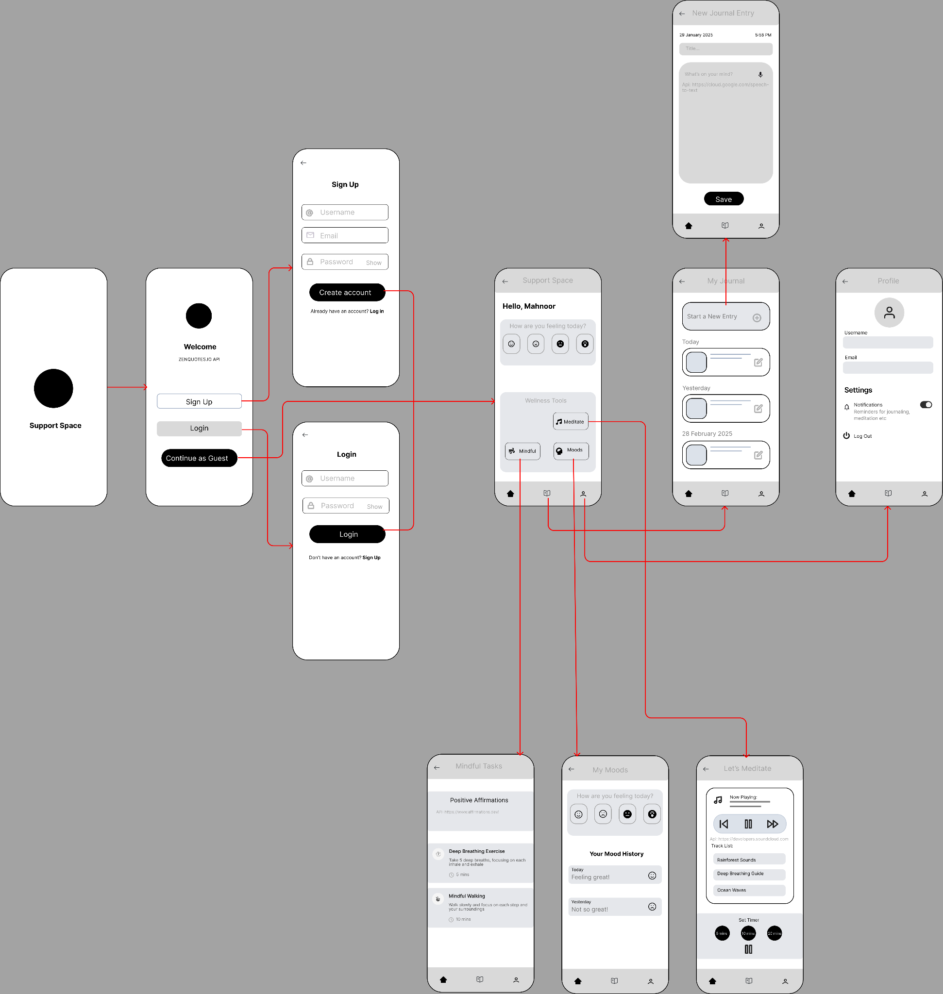

*Figure 1: SupportSpace Figma Wireframe*

SupportSpace app navigation flow is designed to be simple, intuitive and user-friendly, ensuring all users can easily access the mental health support features.

1. **Splash Screen-** The app opens with the splash screen displaying the SupportSpace logo and transitions to the welcome screen after a few seconds.
2. **Welcome Screen-** Users are presented with the option to sign up (create an account), log in or continue as a guest to access the app without an account. 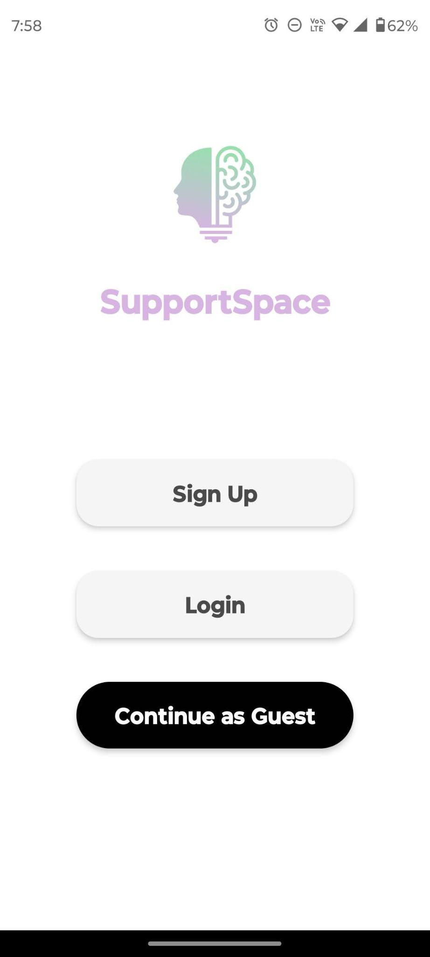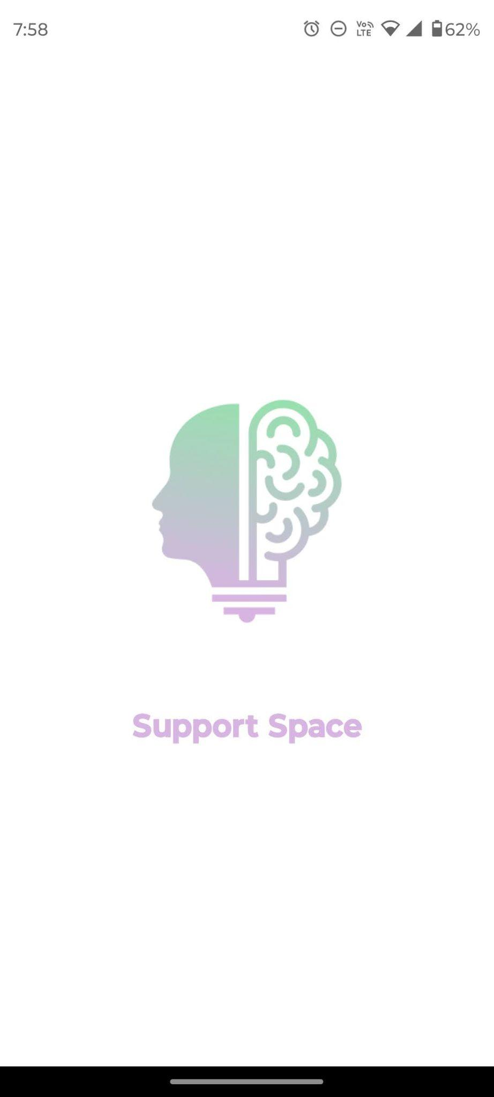

*Figure 2, Figure 3*

1. **Sign Up Screen-** Users enter a username, email and password to sign up using Firebase authentication.
2. **Login Screen-** Users provide login credentials to access the app with Firebase authentication.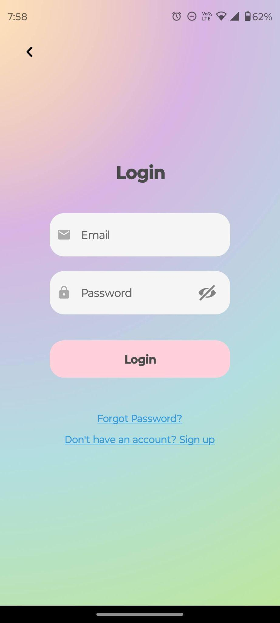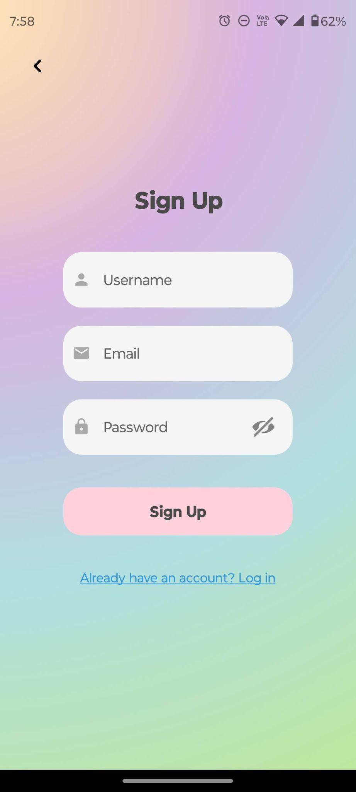

*Figure 4, Figure 5*

1. **Home Screen (Main Dashboard)-** After logging in or continuing as a guest, users arrive on the main screen. It displays a welcome message, a mood selection panel (e.g., Happy, Neutral, Not Great, Angry), and access to Wellness Tools–Meditate, Mindfulness and Moods. 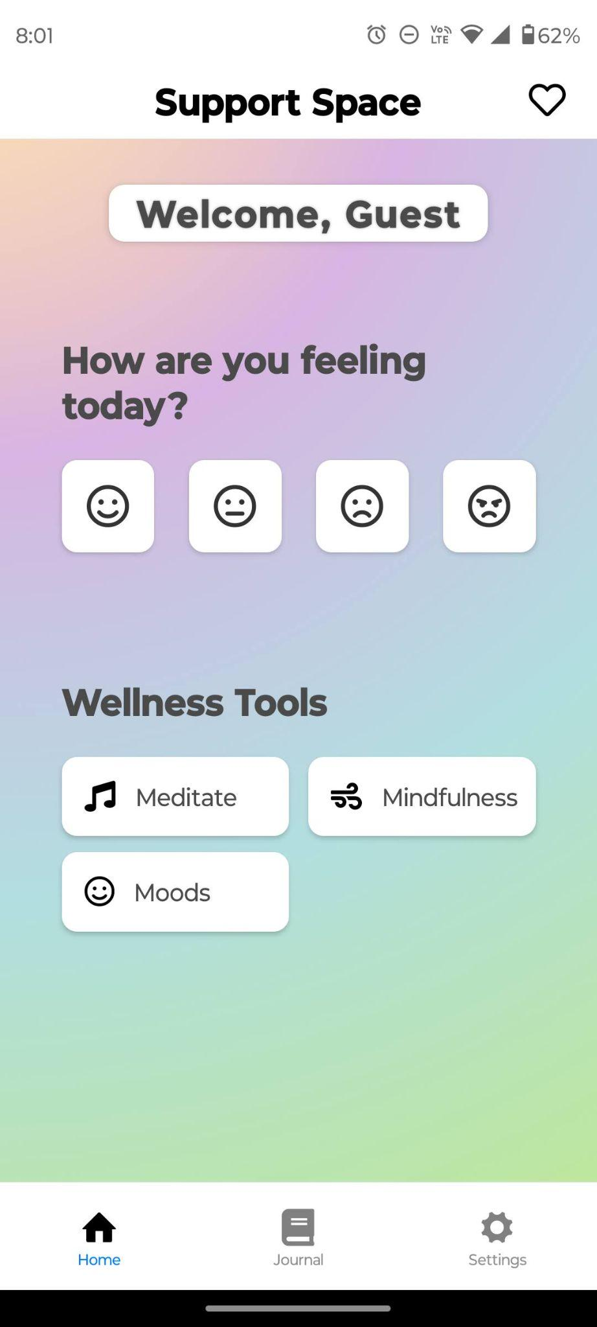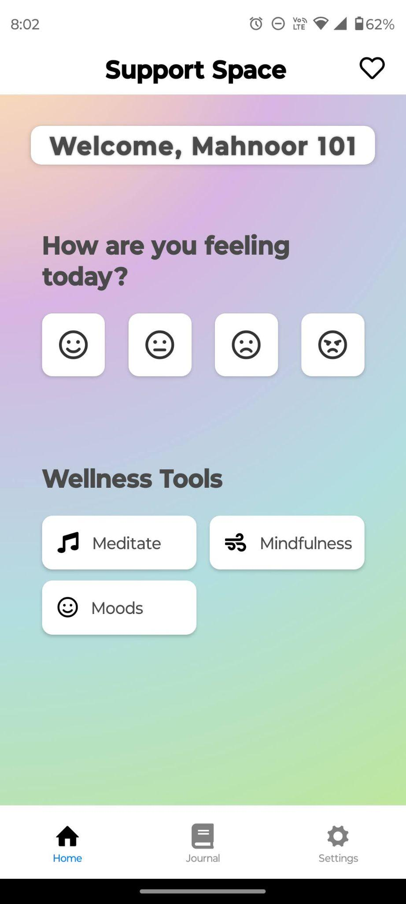

*Figure 6, Figure 7*

1. **Journaling Screen-** From the bottom navigation bar, users can navigate to the My Journal screen, which displays named journal entries by date. Users can write a New Journal Entry by tapping the button, and they can edit previous entries by tapping the pencil icon. 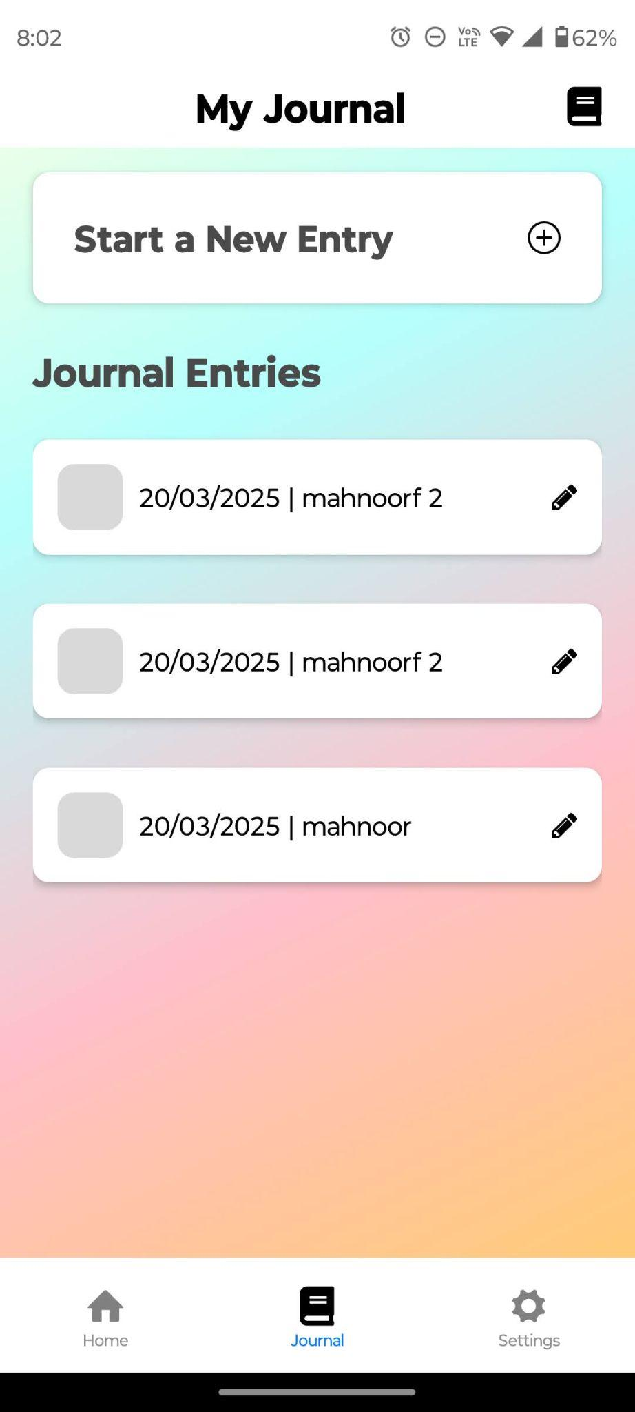

*Figure 8*

1. **New Journal Entry Screen-** Users can add any thoughts on their mind in the new entry section with a title. Only entries by logged-in users can be saved to the offline SQLite database using the Save button. If a previous entry is being edited, it can be deleted using the Delete All Data button. The current date and time of the journal entry are saved.

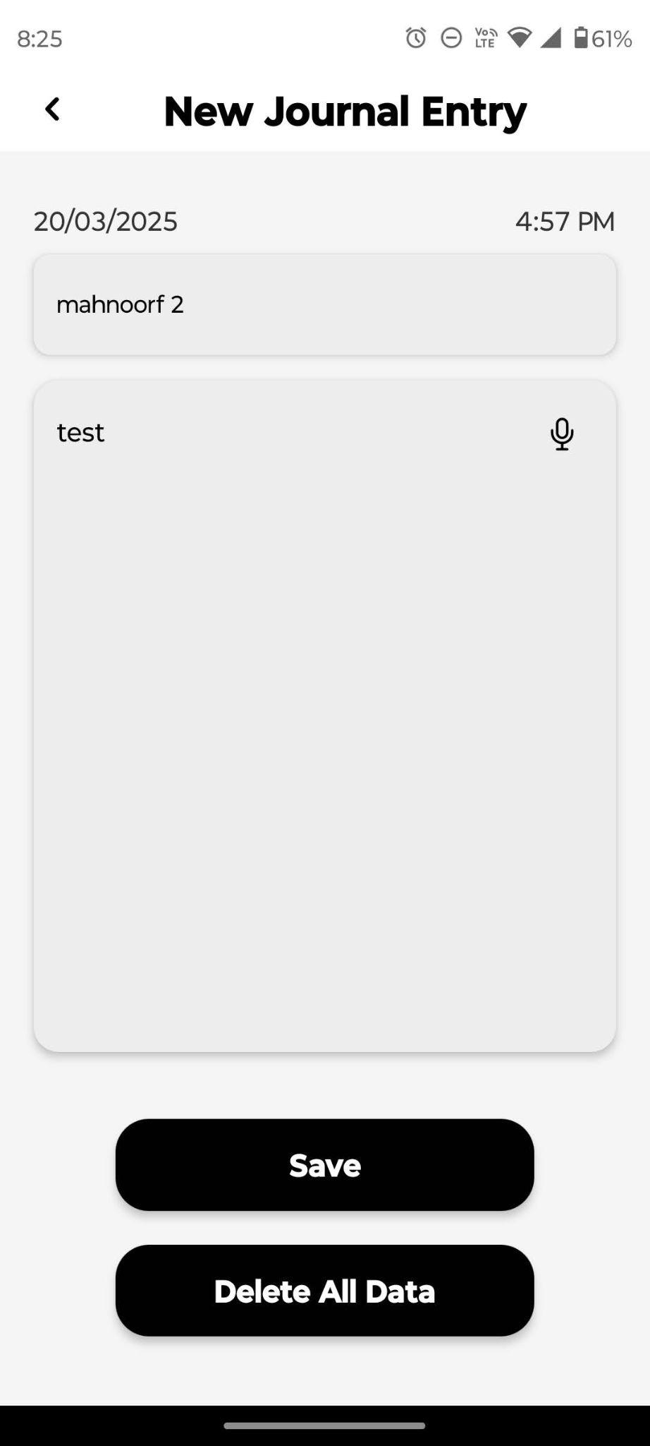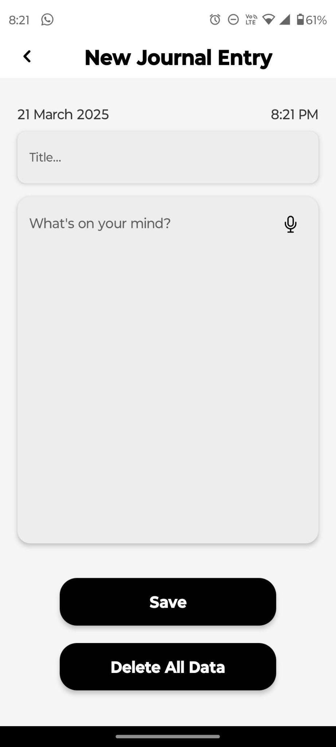

*Figure 9, Figure 10*

1. **Mindful Practices Screen-** A positive affirmations API [<https://www.affirmations.dev/>] is implemented where users can see a new affirmation every time they refresh the screen or tap the affirmation text. Users can see a list of mindful practices they can follow.
2. **Meditation Screen-** Logged-in users will be able to play any calming sound or audio to meditate to. Users can use the timer for meditation.
3. **Mood History Screen-** My Moods screen displays the moods of logged-in users by date and time. Guest users will not be able to save their moods.

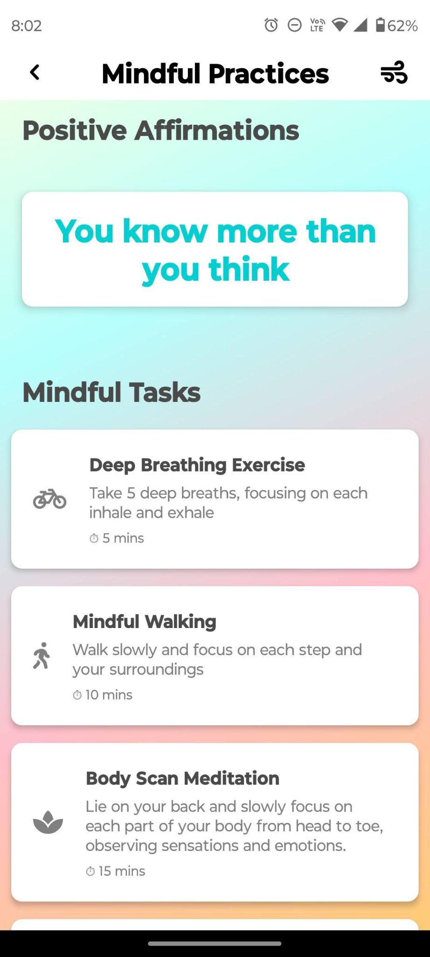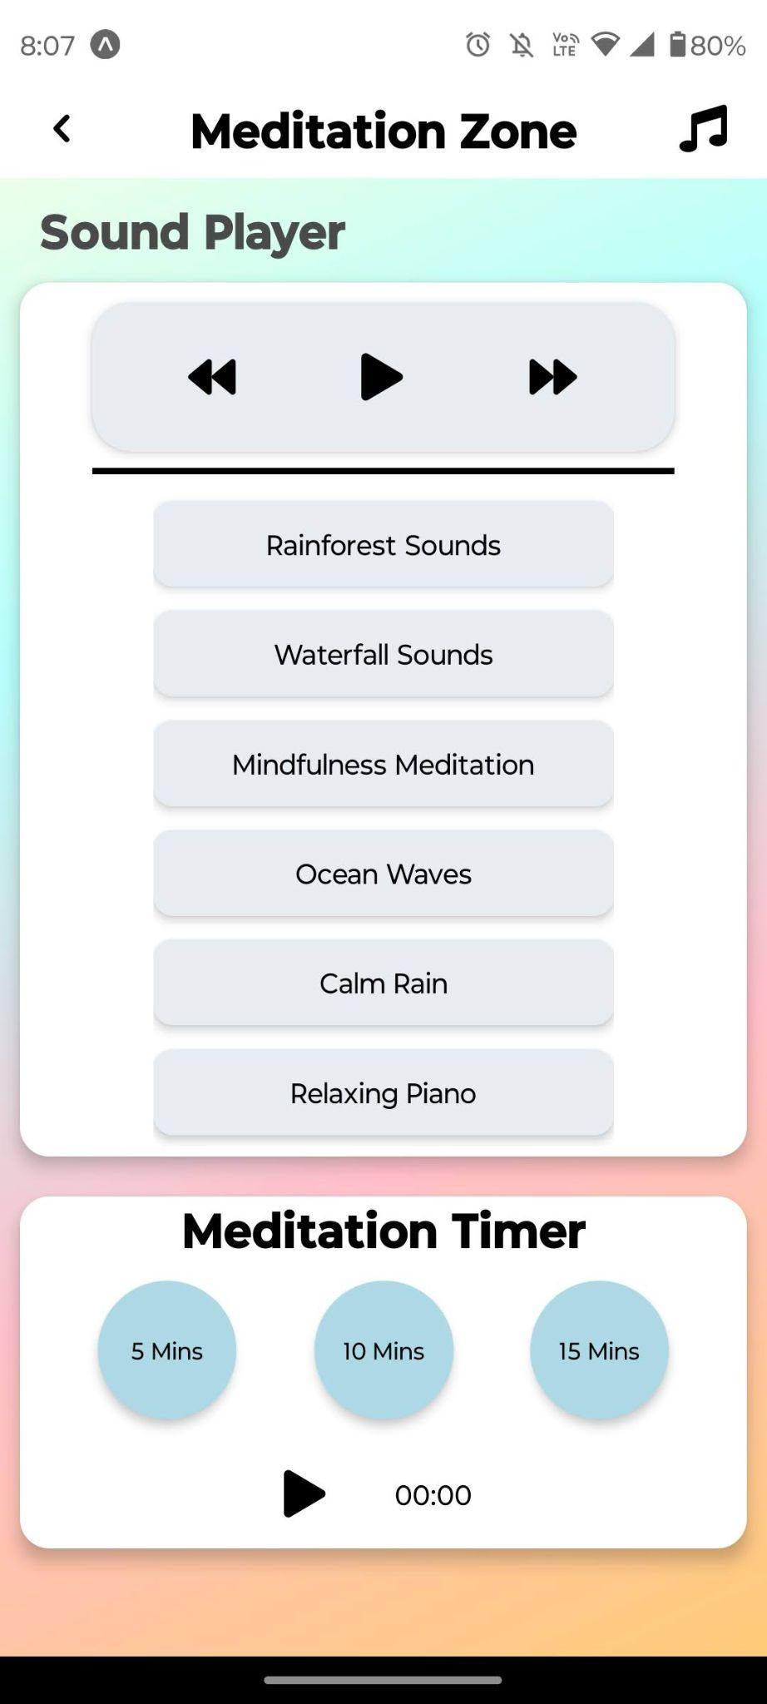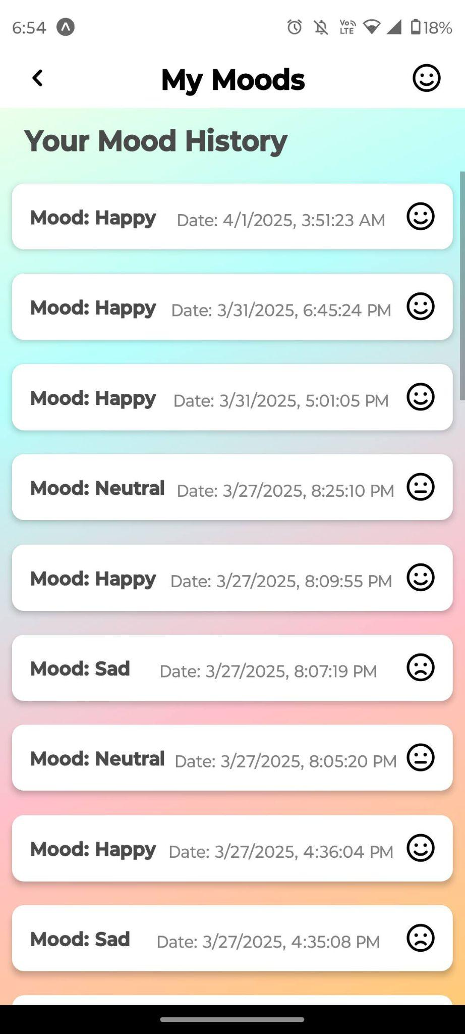

*Figure 11, Figure 12, Figure 13*

1. **Settings Screen-** From the bottom navigation bar, users can navigate to the profile and settings screen. This displays user info (username, email), a delete account button and a logout button. 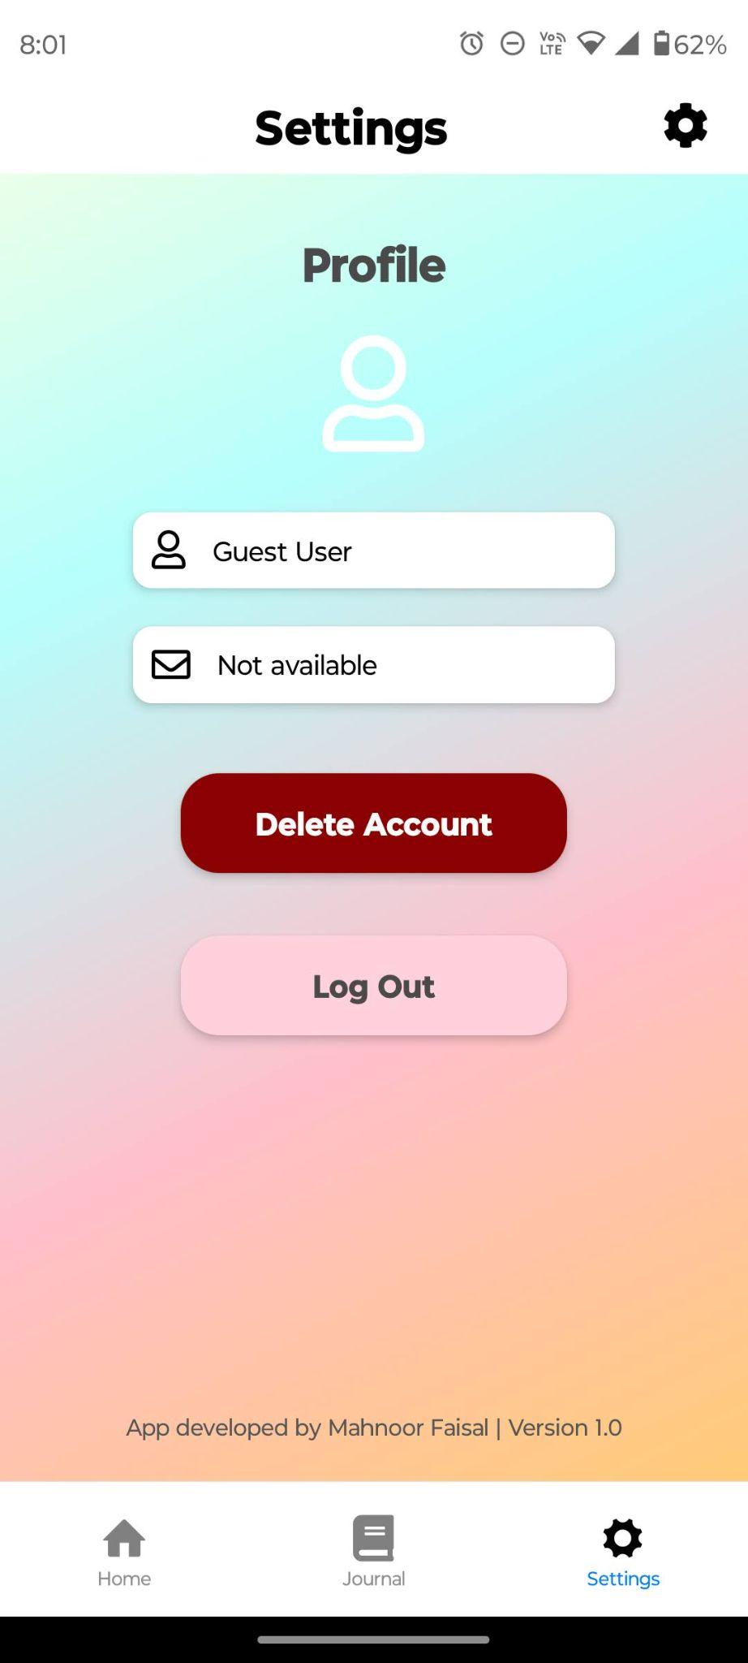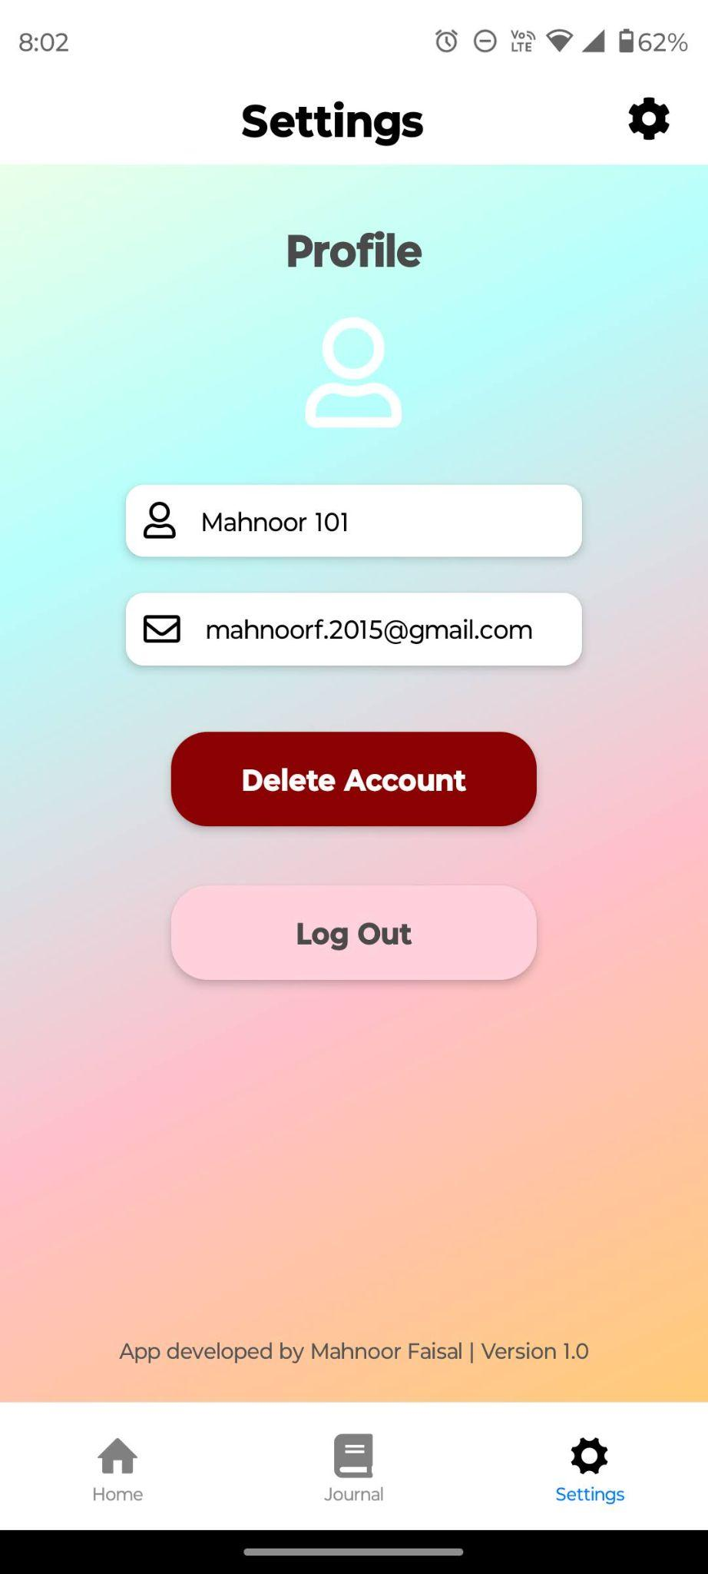

*Figure 14, Figure 15*

## Technical Design

SupportSpace was designed and built using multiple technologies and frameworks.

* Frontend & Backend used React Native + JavaScript.
* Sandbox Environment and Hosting on Expo Go.
* User Authentication used Google Firebase
* Journal entries and mood selections are saved on offline SQLite databases
* APIs integration used daily positive affirmations [<https://www.affirmations.dev/>].
* Icons used Entypo, Font Awesome 5, and React Native Material Icons.
* Integrated Development Environment (IDE) used Visual Studio Code.

## Data Design and Database Implementation

SupportSpace has 2 offline SQLite database tables. The first is moods.db.

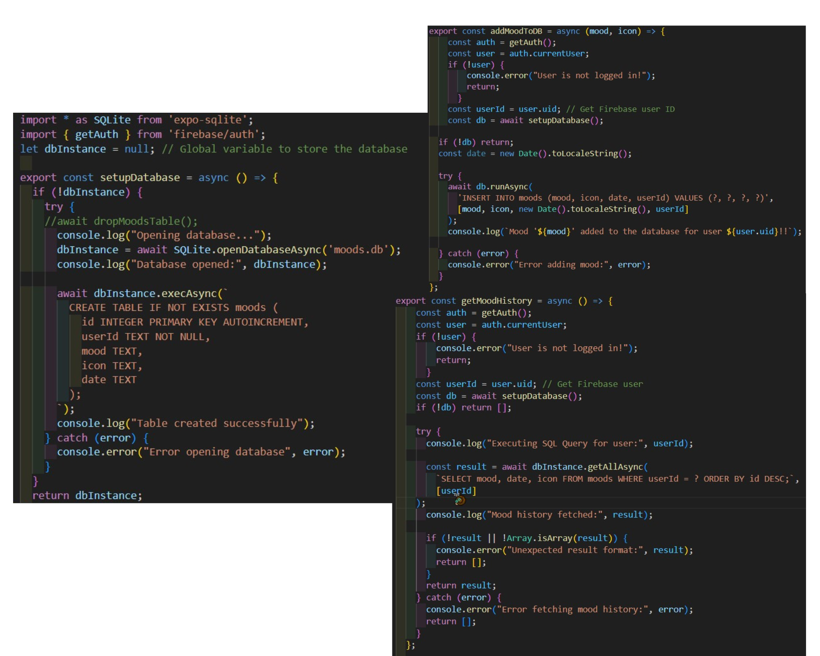

*Figure 16*

As shown in Figure 16, SupportSpace utilizes a local SQLite database named moods.db to securely store user mood entries on the device. The information is saved in the table named moods. The image above illustrates three core functions for setting up and interacting with this database.

1. Database is initialised using **setupDatabase().** This uses Expo-SQLite to create the moods table.
2. Add a Mood Selection using **addMoodToDB(mood, icon).** After authenticating user via Firebase, a new mood is inserted into the moods table alongside mood, icon and timestamp.
3. Retrieve Mood History using **getMoodHistory().** After authenticating the current user, the mood entries for the logged-in user are fetched and displayed.

This structure ensures that mood data is lightweight, well-organized, and filterable by user ID, making it suitable for personal mental health tracking.

The second SQLite database is journal.db.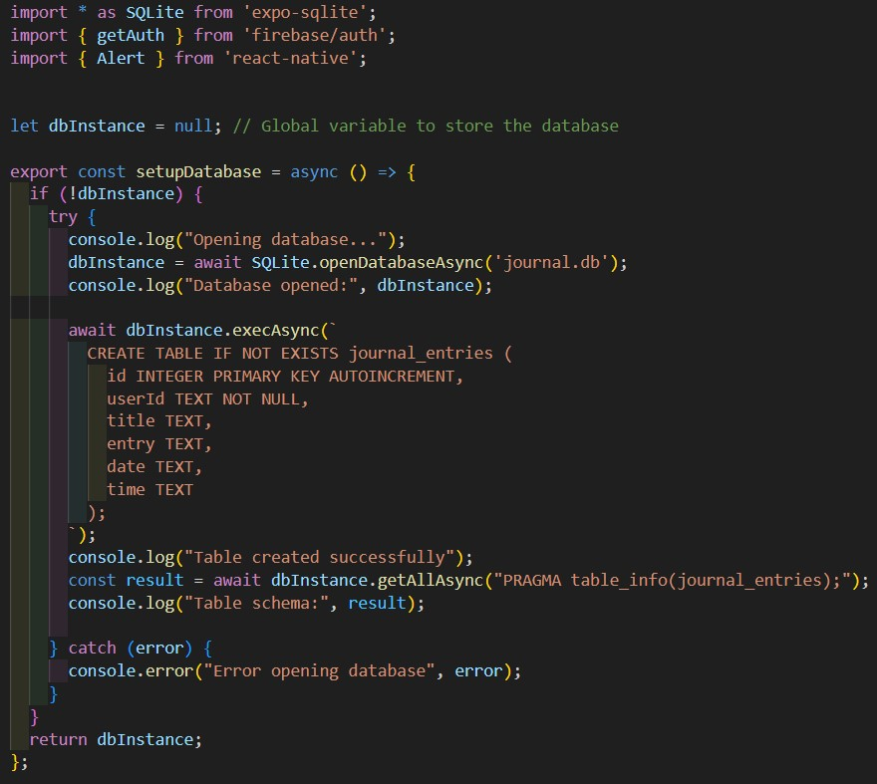

*Figure 17*

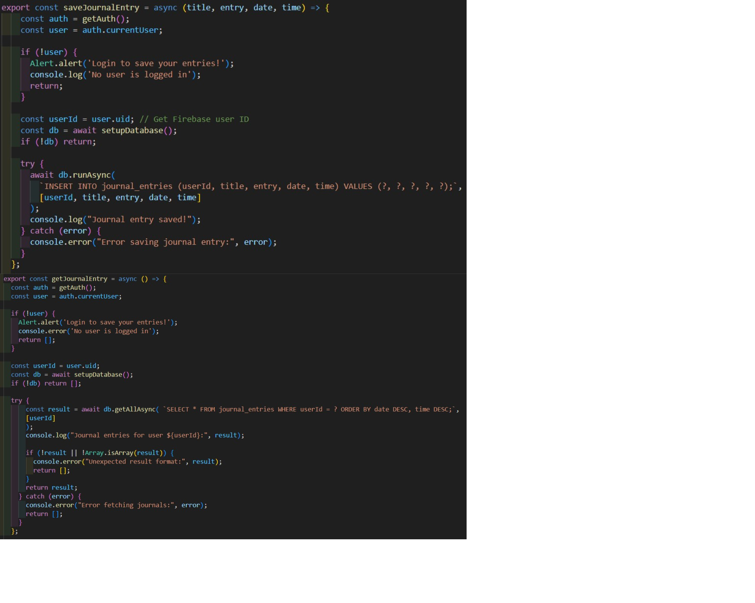

*Figure 17*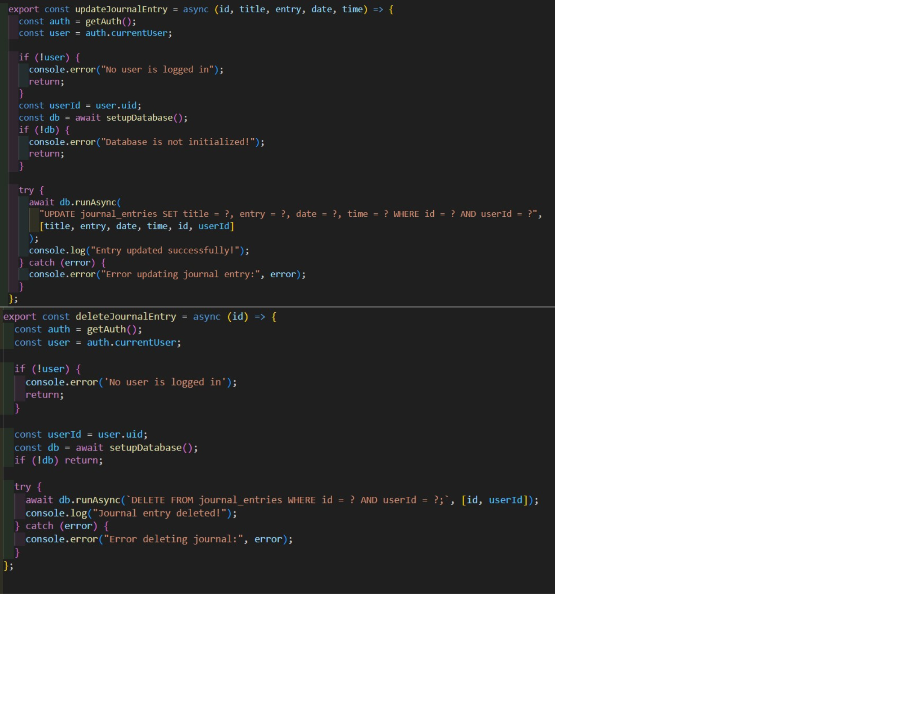

*Figure 17*

As shown in Figure 17, SupportSpace utilizes a local SQLite database named journal.db to securely store user journal entries on the device. The information is saved in the table named journal_entries. The image above illustrates five core functions for setting up and interacting with this database.

1. Database is initialised using **setupDatabase().** This uses Expo-SQLite to create the journal_entries table.
2. Save a New Journal Entry using **saveJournalEntry().** After authenticating user via Firebase, a new journal entry is saved in the database.
3. Retrieve Journal Entries using **getJournalEntry().** After authenticating the current user, the journal entries for the logged-in user are fetched and displayed.
4. Update Journal Entries using **updateJournalEntry().** This allows users to edit an existing journal by updating the title, content, date or time.
5. Delete Journal Entries using **deleteJournalEntry().** This enables users to delete a specific journal entry by ID.

This design provides full CRUD (Create, Read, Update, Delete) functionality for journal entries, allowing users to manage their thoughts, reflections, or notes directly within the app.

Finally, Firebase Authentication manages user access and identity within the application. It supports both registered users (who sign in) and anonymous guest users. This way allows for flexibility and accessibility.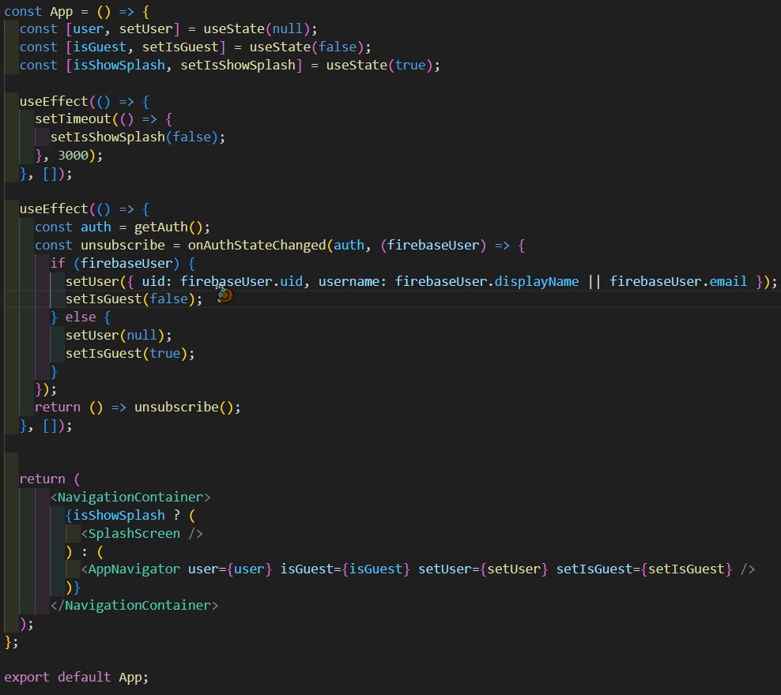

*Figure 18*

According to Figure 18, the SupportSpace App is set up with a separate Firebase user and guest user permissions. This way, the app can differentiate between which kind of user is using the app.

1. **Registered Users** have their credentials securely stored and managed by Firebase. After successfully logging in, a unique user ID (UID) is generated and used in the app to associate data such as mood selections and journal entries for that user.
2. **Anonymous Guest Users** can access the app without registering. The app still generates a UID for each guest session. However, guest users cannot access some features such as the mood entry, journal entries, and meditation sound player. Guest users will receive a pop-up alert if they try to use these features.

## Security Design

To ensure security, minimal user data is collected. Linking both moods and journal_entries tables to Firebase Auth UIDs (userId), the system ensures that each user sees only their own data and that data privacy and separation exist between multiple users on the same device. There is secure offline access (SQLite), as all features can be used offline except for the Firebase login authentication, which requires internet connectivity.

## Development Testing

Manual testing was constantly carried out during the app development process. After deploying the app on Expo, it was tested on Android and iOS devices. The main focus areas included screen navigation, Firebase authentication, journaling functionality and mood selection entry.

## Conclusion

This chapter detailed the steps and design process of SupportSpace, emphasising technical choices, system layout, user interface and data handling strategies. This design focused on balancing simplicity with functionality, ensuring users feel comfortable and engaged while using the app.

# Chapter 6 – Implementation and Testing

## Introduction

This chapter outlines the implementation and testing phases of SupportSpace while providing insights into how each component was developed, how various features were integrated and how testing ensured a secure and responsive user experience.

## Implementation Plan

The tasks were implemented based on feature dependencies:

* User Authentication (Firebase)
* App Navigation
* Mood Tracker with database and suggested tasks
* Journal feature with database
* Mindful Practice feature with API
* Meditation feature with downloaded sounds and a timer
* User Interface and Design
* Settings Screen
* Expo App Deployment

This way, user authentication and app navigation were implemented and responsive before introducing any mood or journal features.

## Development Environment

As mentioned previously, SupportSpace was built using React Native and JavaScript to design the application's front-end and back-end, ensuring cross-platform compatibility. It was developed within the Expo Go sandbox environment, which allowed testing and building for both Android and iOS devices.

Google Firebase was used to manage user authentication, enabling seamless sign-up and login functionality. SQLite was implemented to store sensitive information such as journal entries and mood data offline.

Development was carried out in Visual Studio Code (VSCode), a robust and flexible integrated development environment (IDE). A daily affirmations API was implemented to support users’ well-being. To enhance the visual appeal and usability of the app, icon libraries like Entypo, Font Awesome 5, and React Native Material Icons were utilized. These tools and technologies were chosen for their ease of use, reliability, and effectiveness in supporting essential mental health features.

The app was continuously tested on physical Android devices throughout the development process to ensure smooth performance, accurate functionality and compatibility. Although the app is cross-compatible, it was not tested on iOS devices until it was deployed. Finally, version control was maintained using Git, with GitHub serving as the remote repository. This was a reliable backup of the codebase that can be accessed below.

SupportSpace GitHub: [<https://github.com/mahnoorcodes/L6_supportspace_app>]

## Coding Standards and Practices

To maintain clarity within the code, CamelCase was used for variable and function names, and each component was modularised and named clearly within the app folder. Comments were added to key logic areas.

## Module and Component Development

The development of SupportSpace involved building several modules and components, each contributing to the app’s core functionality and user experience. Each module and component was developed in VS Code using various libraries, frameworks and APIs.

1. **User Authentication Module:** 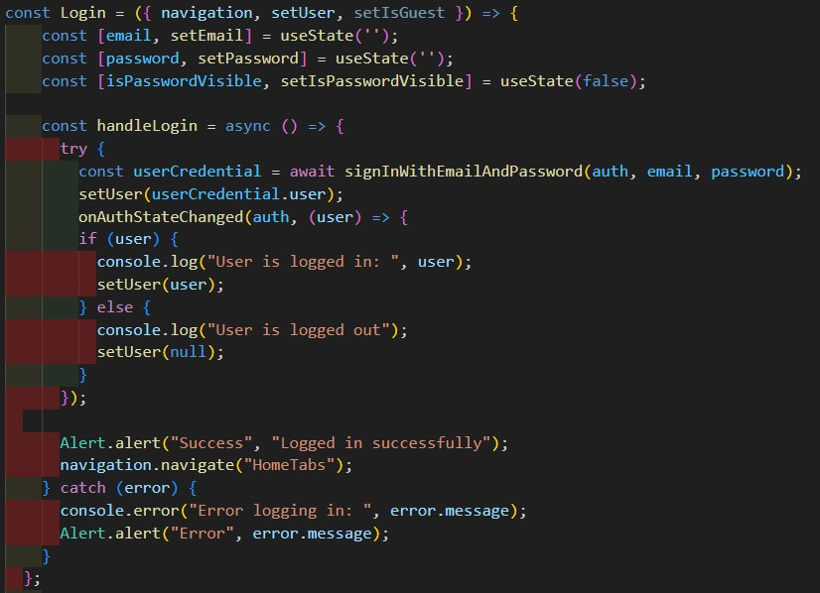

*Figure 19*

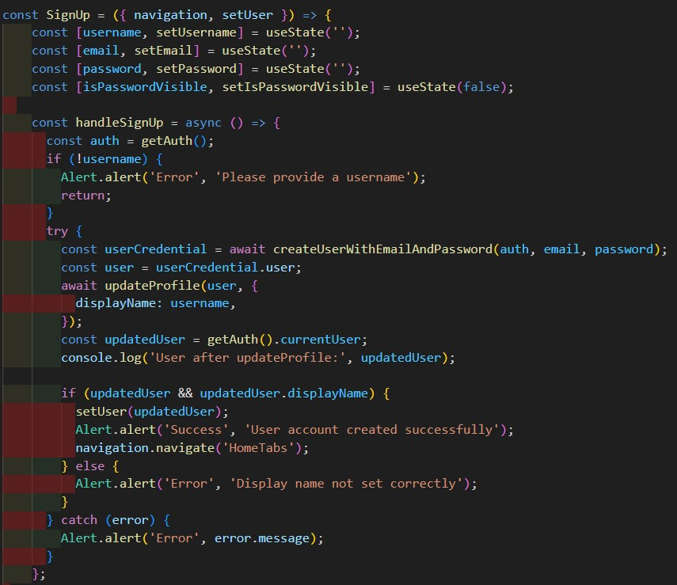

*Figure 20*

This module was built using Firebase Authentication, allowing users to securely sign up, log in, continue as a guest or log out. Firebase provided a secure and easy-to-use backend for handling authentication. Figure 19 shows how login authentication for returning users is handled. Figure 20 shows how sign-up authentication for new users is handled. The validation checks and error messages appear in alerts for incorrect usernames or passwords.

1. **Mood Selection and Task Suggestions Module**

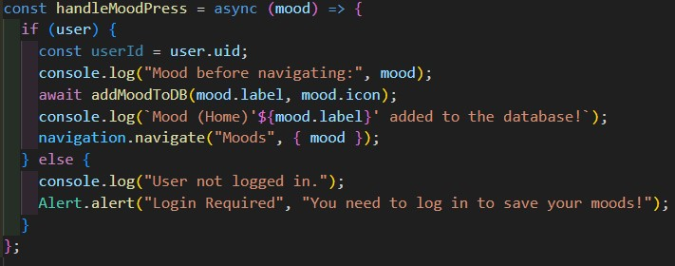

*Figure 21*

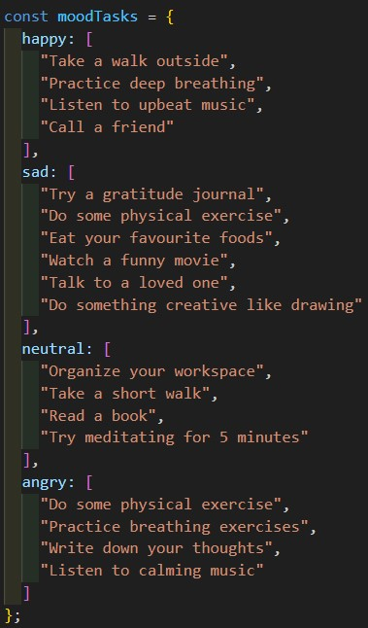*Figure 22*

The mood tracking module allows users to select their current mood from 4 mood icons– Happy, Neutral, Sad and Angry. The mood selected is then added to moods.db stored locally using SQLite, making it accessible even when offline. After selecting a mood, the user is recommended a task based on the mood, as shown in Figure 22. Finally, the mood screen displays a timestamped mood history for each user.

1. **Journal Entry Module**

*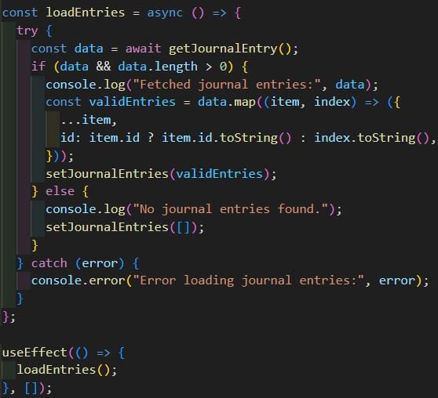Figure 23*

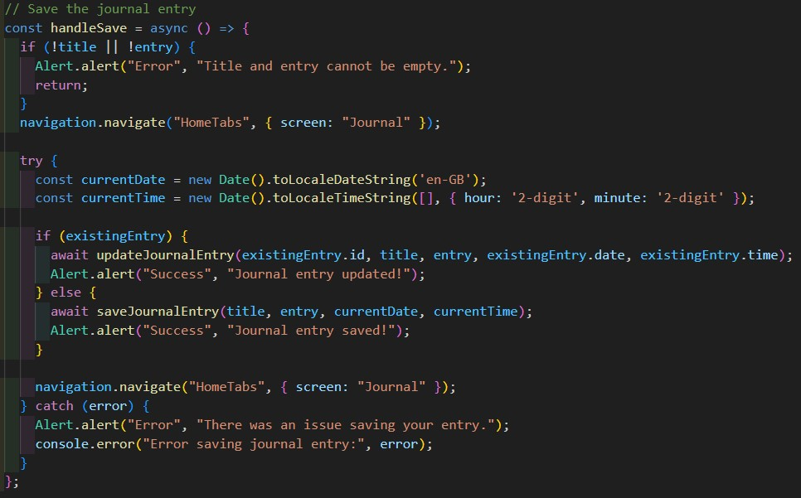

*Figure 24*

The journal screen displays the fetched user journal entries according to the current logged-in user ID (UID). This is displayed according ot date and time. This screen features a New Journal Entry button, which takes users to a screen where they can write and save personal journal entries. It was developed with a combination of textInput components from React Native, and the data is saved in journal. db, which is an SQLite offline database.

1. **Positive Affirmations Module**

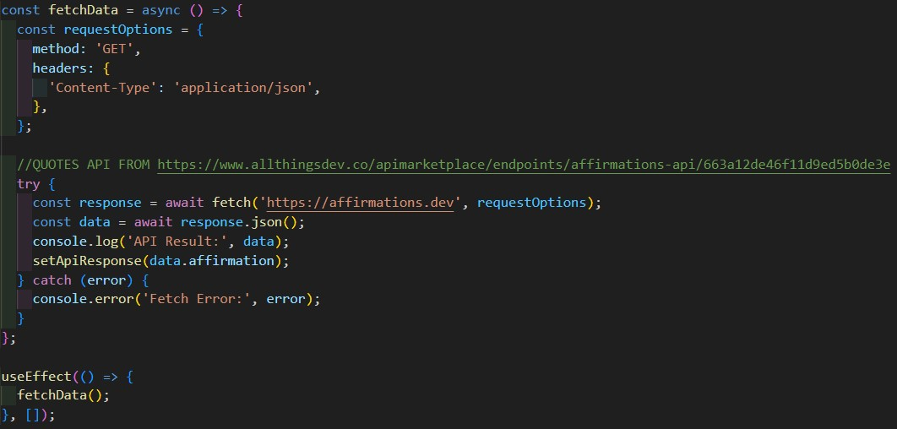

*Figure 25*

The affirmations feature was implemented using a third-party API that fetches motivational and positive affirmations. This module updates when the screen refreshes or the user clicks on the text. The data was fetched using asynchronous fetch calls, with loading and error handling states. [<https://www.allthingsdev.co/apimarketplace/endpoints/affirmations-api/663a12de46f11d9ed5b0de3e>]

1. **Meditation Sound Player Module**

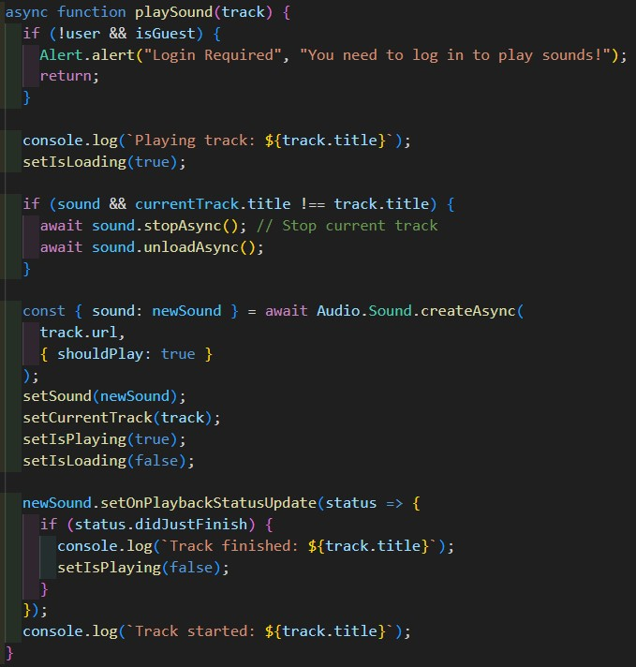

*Figure 26*

The meditation sound player plays sounds and audio from a selected list of MP3 downloaded audios from YouTube. State components are used to ensure the correct audio is loading and playing.

1. **App Navigation Components**

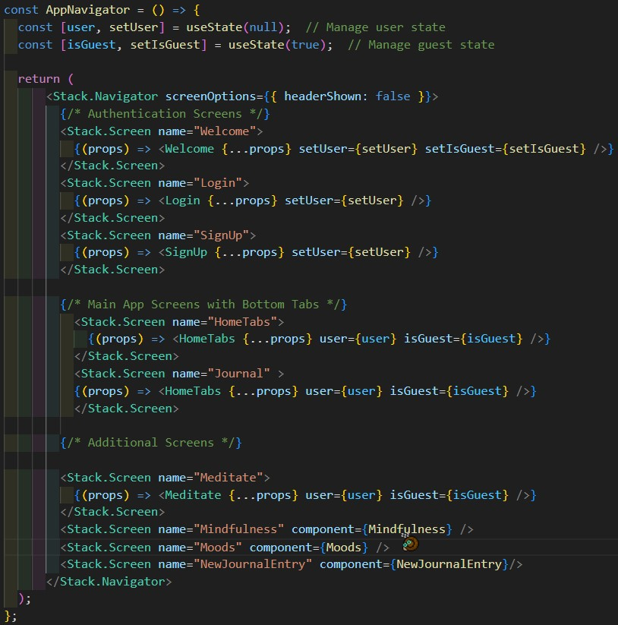

*Figure 27*

The app navigation is the most crucial part of the application. It was built using React Navigation, allowing smooth transitions between all the screens. The user and guest states were set to ensure that which user can use each screen. Consistent styling was maintained across all the screens using custom themes and icon libraries like Entypo, Font Awesome 5 and React Native Material Icons. Managing navigation was undoubtedly one of the hardest parts of development.

1. **Settings Section:** The static content components in the settings screen displayed the current user’s email and username as well as buttons for deleting the account and logging out.
2. **Data Storage and Error Handling:** As mentioned in previous chapters, all user-generated content is stored locally using SQLite to ensure privacy and offline access. Throughout the app, various error-handling mechanics were implemented to manage failed data fetches, incorrect user credentials, and unexpected issues in navigation or loading. Try-Catch blocks, user alerts and fallback states were added for a more resilient user experience.

## User Acceptance Testing (UAT)

User Acceptance Testing involved sending the deployed SupportSpace app to 9 people. 5 of these people were Android phone users while 4 were iOS iPhone users. They were each asked to sign up or continue as a guest, add a mood entry, write and save a journal entry and play a meditation sound.

Feedback collected included:

* Praise for clean and aesthetic UI and ease of use.
* All features were working properly for both Android and iOS users, except for the journal entry feature for iOS users.
* Suggestions to add notifications and more mood options.
* All users found the app navigation fast and seamless.

## Performance Testing

The app’s performance testing was conducted manually using a physical Android device with Expo Go. The app load time took under 3 seconds from the splash screen to the welcome screen. If it took any longer, it meant there were bugs or errors. The app worked properly if the read/write times in SQLite and Firebase were done instantly with a “Success!” alert.

## Bug Tracking and Errors

Throughout the app testing and development process, I encountered countless bugs, errors, parse errors, database connection issues, and build failures. These errors often emerged from incorrect configurations, syntax mistakes, or integration problems between various components like Firebase, SQLite, and third-party APIs.

To effectively troubleshoot and debug, I relied heavily on debugging tools and AI-based support systems. GitHub Copilot provided real-time code suggestions and helped identify logical issues as I typed, while ChatGPT explained complex issues, offering easy solutions and generating relevant fixes.

These tools sped up the debugging process and helped me understand the cause of these problems.

## Conclusion

This chapter covered the implementation and testing process of the mobile app. From planning modular implementation to testing, every aspect was carried out to ensure user experience and functionality remain the main priority.

# Chapter 7 – Evaluation of the Product

## Introduction

This chapter presents a detailed evaluation of the mobile application *SupportSpace*, focusing on its overall effectiveness, usability, and performance. Evaluating the product is essential to understand how well it meets its intended goals and user needs.

## Product Evaluation

The primary goal of SupportSpace was to provide a simple and user-friendly mobile app to support mental health and wellbeing through features like mood tracking, personal journaling and daily affirmations.

The app effectively enables users to sign up and log in to utilise all features such as selecting their moods, writing journal entries, listening to calming sounds and receiving daily affirmations. Usability testing on both Android and iOS devices showed that the user interface is intuitive, visually appealing and easy to navigate. However, the journal feature does not work properly on iOS devices. Nevertheless, the use of icons and a clean layout contributed positively to the user experience. The feedback from users confirmed that the app is accessible and easy to use.

The app also has no major performance issues or noticeable lags during usage. The offline storage with SQLite is fast and reliable, ensuring the mood and journal data are saved securely. Firebase handled all authentication seamlessly, allowing both users and anonymous guests to access. I followed many YouTube tutorials to implement SQLite and Firebase integration in the app.

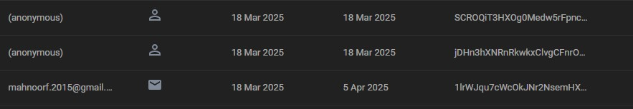

*Figure 28*

As shown in Figure 28, this is the Firebase Console for SupportSpace. Whenever a user signs up or enters as a guest, it is recorded with the date and a randomly generated UID.

The main issues and constraints encountered were poor planning and time management. The app design and planning began in January, while the development began in February. With proper planning and more time, more features could have been added, such as a wider range of moods, reminders and push notifications and an AI-powered chatbot.

## Conclusion

The evaluation indicated that SupportSpace is a well-functioning and proper mobile application that supports the goals of sporting mental health through self-monitoring and encouragement. As this is my first proper mobile application and project, I am very proud of all the work and effort I put in.

# Chapter 8 – Critical Evaluation

## Introduction

This chapter offers my reflection and thoughts on the development process of SupportSpace, based on the decisions, experiences and lessons learned throughout the project.

## Reflections

Most of the app objectives have been met successfully, such as integration with Firebase for authentication and SQLite for offline data storage. All the app features were implemented properly without any errors or issues.

However, some features such as advanced mood analytics, personalised content, and voice-journalling were scaled down due to time constraints and technical complexity. This led to adjustments in planning during development.

The most significant challenges I faced were in setting up and managing the various databases. There were countless bugs, unexpected builds and database errors. Fortunately, sites like StackOverflow and YouTube, alongside AI tools like GitHub Copilot and ChatGPT, helped identify and overcome all technical hurdles.

Utilising Git and GitHub for version control was the most helpful as it helped me manage code and track the evolution of ideas and improvements without worrying of data loss.

Another challenge was balancing the simple design with complex functionality. I made sure to choose pleasing colors and a simple layout to optimise performance across different devices.

## Conclusion

This critical evaluation highlights the personal growth and technical development achieved while building SupportSpace. It was an insightful learning experience that involved overcoming technical and logic challenges while managing time constraints and user feedback.

# Chapter 9 – Conclusions

Summary of Findings

The SupportSpace project successfully developed a functioning mobile application that effectively supports mental health by integrating mood tracking, offline journaling, calming sounds and positive affirmations. Throughout the development process, the app was tested continuously on physical Android devices, ensuring reliability and responsiveness. Some key findings include the app’s efficient handling of user authentication via Firebase, robust offline data storage with SQLite, and an intuitive, visually engaging user interface enhanced by third-party icon libraries. These outcomes demonstrate the project’s ability to meet its core functional and usability goals.

## Recommendations for Future Work

Based on the research and insights in this paper, several future improvements can be made:

* **Advanced Mood Data Analytics:** Providing users with insights into their mood trends and journaling patterns over time. This can use AI implementation.
* **Broader Testing:** Conducting extensive testing across various devices and operating systems to ensure compatibility and robustness.
* **Community Support:** A community space for users to chat on the platform with each other.
* **Voice-based Journalling:** This feature was added using a third-party API; however, the API had limited recording time, so this feature was scrapped at the end.
* **AI-Support Chatbot:** Provide users with 24/7 support via chat.

## Closing Remarks

In conclusion, SupportSpace is a successful integration of modern mobile technologies with mental health support. The project not only met its stated objectives but also provided insights into the challenges and opportunities when developing digital health solutions.

Developing this app has been a long journey of growth as I taught myself how to build an app from scratch while conducting extensive research. I am very grateful to my family, friends, classmates and teachers for supporting me in this project. Their valuable insights and feedback helped improve SupportSpace and lay a solid foundation for future innovations that can further enhance mental health through technology.

# References

**[1]** S. Z. Chawla and P. N. Sharma, "Mobile Application for Mental Health Using Machine Learning," *ResearchGate*, Feb. 2023. [Online]. Available:<https://www.researchgate.net/publication/368686642_Mobile_Application_for_Mental_Health_Using_Machine_Learning>. [Accessed: 13-Mar-2025]

**[2]** H. A. P. Haroz, S. Ritchey, P. Bassuk, and G. R. Bond, "Mobile Mental Health: Opportunities and Challenges," *World Psychiatry*, vol. 21, no. 2, pp. 133-134, June 2022. [Online]. Available:<https://onlinelibrary.wiley.com/doi/pdfdirect/10.1002/wps.20883>. [Accessed: 15-Mar-2025]

**[3]** J. A. Naslund, G. A. Aschbrenner, L. A. Marsch, and S. J. Bartels, “The future of mental health care: peer-to-peer support and social media,” *Annals of Family Medicine*, vol. 16, no. 4, pp. 338–340, Jul. 2018. [Online]. Available: <https://www.annfammed.org/content/16/4/338> [Accessed: 4-Apr-2025]

**[4]** A. Mahendran et al., "Mental health apps in China: A systematic app store and literature review," *npj Digital Medicine*, vol. 6, no. 1, pp. 1–12, 2023. [Online]. Available:<https://www.nature.com/articles/s41746-023-00760-8> [Accessed: 4-Apr-2025]

**[5]** Michelle Reid**,** "Technology and Mental Health: How Innovation Supports Emotional Well-being," UserWay, Mar. 2023. [Online]. Available: <https://userway.org/blog/technology-and-mental-health/#:~:text=AI%2Dpowered%20chatbots%20and%20virtual,referrals%20to%20mental%20health%20professionals>. [Accessed: 4-Apr-2025]

**[6]** A. Wasil, J. Venturo-Conerly, R. Shingleton, and J. Weisz, “A review of popular smartphone apps for depression and anxiety: Assessing the inclusion of evidence-based content,” *Health Informatics Journal*, vol. 26, no. 2, pp. 1616–1627, Jun. 2020. [Online]. Available: <https://doi.org/10.1177/1460458219896492> [Accessed: 4-Apr-2025]

# Appendices

Appendix 1 – Project Proposal Form

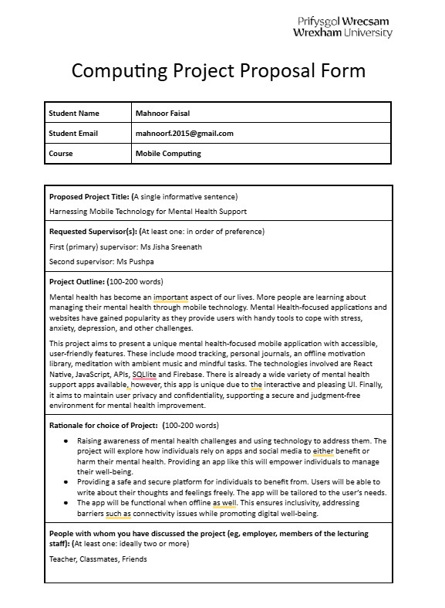

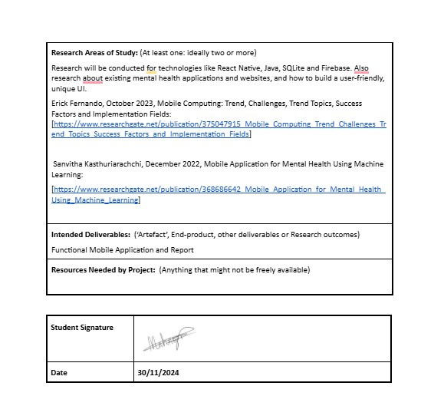

Appendix 2 – Project Specification Form 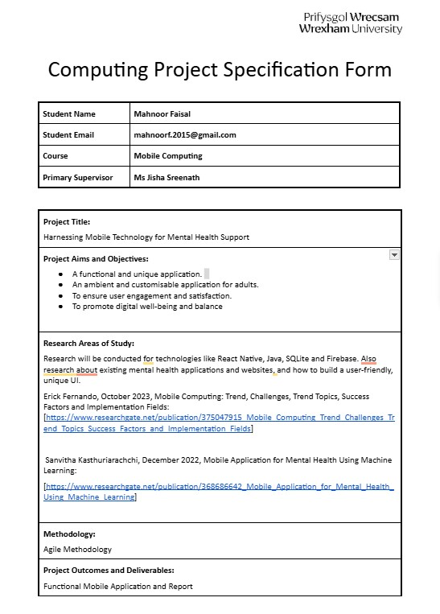

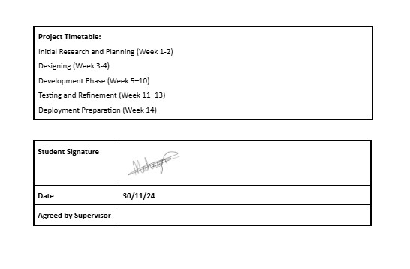

Appendix 3 – SupportSpace Wireframe on Figma

